Signatures/Watermarks in LR or PS and renaming photos with Android or iPhones. Creating Presets for LR and samples for use with Sandhills Photography Club competitions and smug mug uploads.

How to add a watermark signature to an image in Lightroom Classic by Scott Kelby.
https://www.youtube.com/watch?v=6UAltE5aua8

Beginner's Guide to Creating a Watermark/Logo in Photoshop by Anthony Morganti
https://www.youtube.com/watch?v=d_oOY2UIGVc
You could use the graphic signature in this video and use it in LR as a graphic just like Scott did in the video before.
Rename images on an android phone:
https://www.youtube.com/watch?v=r3hFoKMdIBI
Rename images on an iphone:
https://www.youtube.com/watch?v=e_AyD8Az5y4
Rename images for iphone ( a second video):
https://www.youtube.com/watch?v=OCMweF6K_Lk

Setting up Presets for export in Lightroom:
https://helpx.adobe.com/lightroom-classic/help/export-presets-settings-plug-ins.html
See samples for SPC Competition, Smug Mug Gallery Upload, Facebook Upload, and Alison – Newsletter upload. These are my settings. You can alter them as you like, but they have worked well for me. Just select a photo in library, click export at the bottom left and the export box will open.
See settings for the following presets for Sandhills Photography Club:
- Competition Preset: Fill out the export box with your information and then click “add” at the bottom left. This will let you create a preset like mine and name it for the SPC Competition. From then on, you will have this when you are preparing a photo for entry into a club competition.
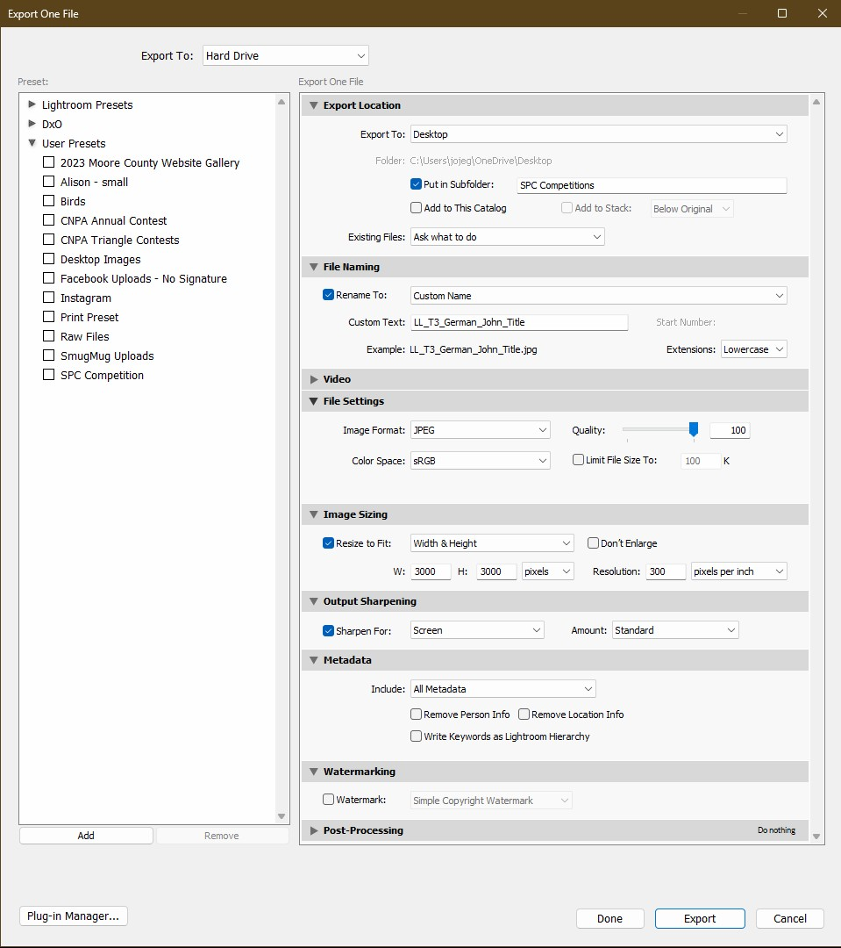

- Smug Mug Galleries: Again fill out the export box like the one below and click “add”. Name this for Uploads to Smug Mug Galleries. Then when you are uploading after an outing or field trip, just click this preset and correct any necessary info (title, etc) and export. This will give you your photos prepared for the smug mug gallery.
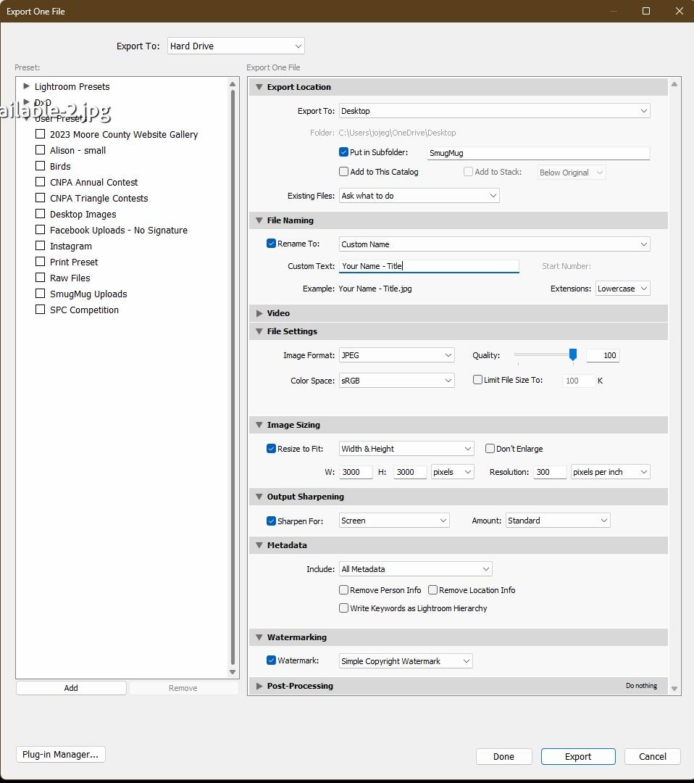

- Facebook: Repeat as before and add to your presets. Then when you want your photos for facebook just use this preset.
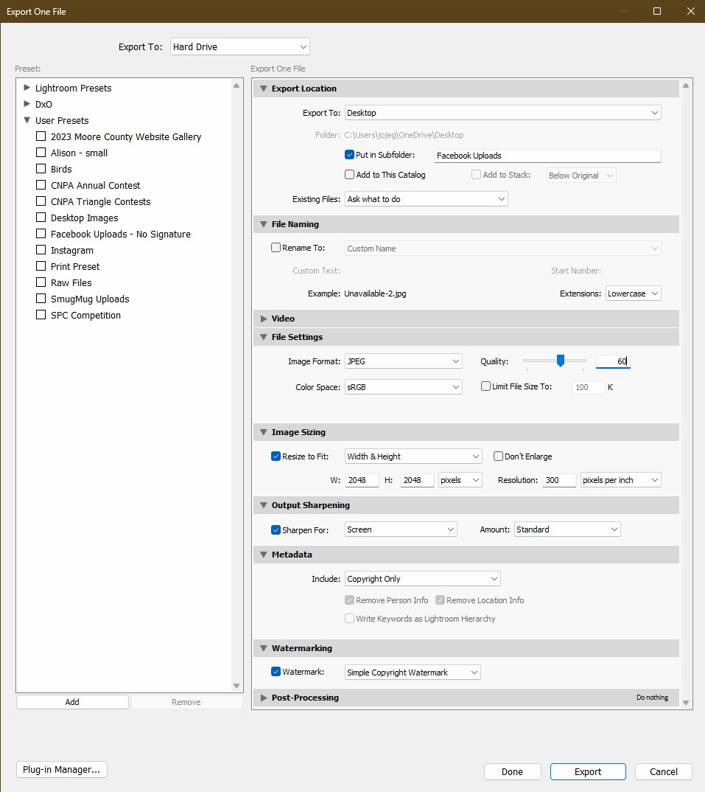

- Small for Alison or newsletter, etc.: Repeat and name preset
